**Name : Aarya Tiwari**

**Batch : B2**

**Roll no. – 16010421119**

**Experiment 1:**

Experiment 1

Code :

<!DOCTYPE html>

<html>

<body>

    <?php

    echo "My first PHP script! <br><br>";

    echo "Basic Functions <br><br>";

    $num1 = 13; // Varible Declaration (Integer)

    $num2 = -15.4;

    $text1 = "Aarya"; // Varible Declaration (String)

    $bool1 = true; // Varible Declaration (Boolean)

    $frands = array("Aarya", "Dhariya", "Pratham", "Dhruv");

    $nums = array(2, 3, 4, 5, 6, 7, 8, 9);

    //Math

    echo "Math Functions <br><br>";

    echo "The First number is " . $num1 . "<br>";

    echo "The Second Number is " . $num2 . "<br>";

    echo "The Addition of them is " . $num1 + $num2 . "<br><br>"; //Addition

    echo "The Subtraction of them is " . $num1 - $num2 . "<br><br>"; // Subtraction

    echo "The Multiplication of them is " . $num1 * $num2 . "<br><br>"; // Multiplication

    echo "The Division of them is " . $num1 / $num2 . "<br><br>"; // Division

    echo "The value of pi is " . pi() . "<br>"; // Value of Pi

    echo "The maximum value in the nums array is " . max($nums) . "<br>"; // Maximum Value

    echo "The minimum value in the nums array is " . min($nums) . "<br>"; // Minimum Value

    echo "The absolute value of Number 2 is " . abs($num2) . "<br>"; // Absolute Value

    echo "The Square Root of Number 1 is " . sqrt($num1) . "<br>"; // Square root

    echo "The Round off for Number 2 is " . round($num2) . "<br>";

    echo "A Randomly Generated Number is " . rand() . "<br><br>";

    //String

    echo "String Functions <br><br>";

    echo "The length of text 'Aarya' is " . strlen($text1) . "<br>";

    echo "The number of words in 'Aarya' is " . str_word_count($text1) . "<br>";

    echo "The reverse of string 'Aarya' is " . strrev($text1) . "<br>";

    echo "The position of 'r' in 'Aarya' is " . strpos("Aarya", "r") . "<br>";

    echo "Replacing 'a' with 's' in 'Aarya' will give " . str_replace("a", "s", "Aarya") . "<br><br>";

    // If-Else

    echo "If-Else Statements <br><br>";

    if ($text1 == "Aarya") {

        echo "The variable has the word 'Aarya' <br>";

    } else {

        echo "The variable doesnt have the word 'Aarya' <br>";

    }

    // ForEach Loop

    echo "ForEach Loop <br><br>";

    foreach ($nums as $i) {

        echo "The number is $i <br><br>";

    }

    // For Loop

    echo "<b>For Loop</b> <br><br>";

    for ($x = 0; $x <= 10; $x++) {

        echo "$x is a number between 0-10 <br>";

    }

    // While Loop

    echo "While Loop <br><br>";

    $y = true;

    $z = 0;

    while ($y) {

        echo "The value of z is $z <br>";

        $z++;

        if ($z == 5) {

            $y = false;

        }

    }

    //Arrays

    echo "Array Functions <br><br>";

    for ($x = 1; $x <= 3; $x++) {

        echo "$frands[$x] is my friend but Dev isnt!! <br>";

    }

    //Date and Time

    $t = date("M");

    if ($t < "20") {

        echo "Have a good day!";

    }

    else{

        echo "Dont have a good day!";

    }

    ?>

</body>

</html>

Output:

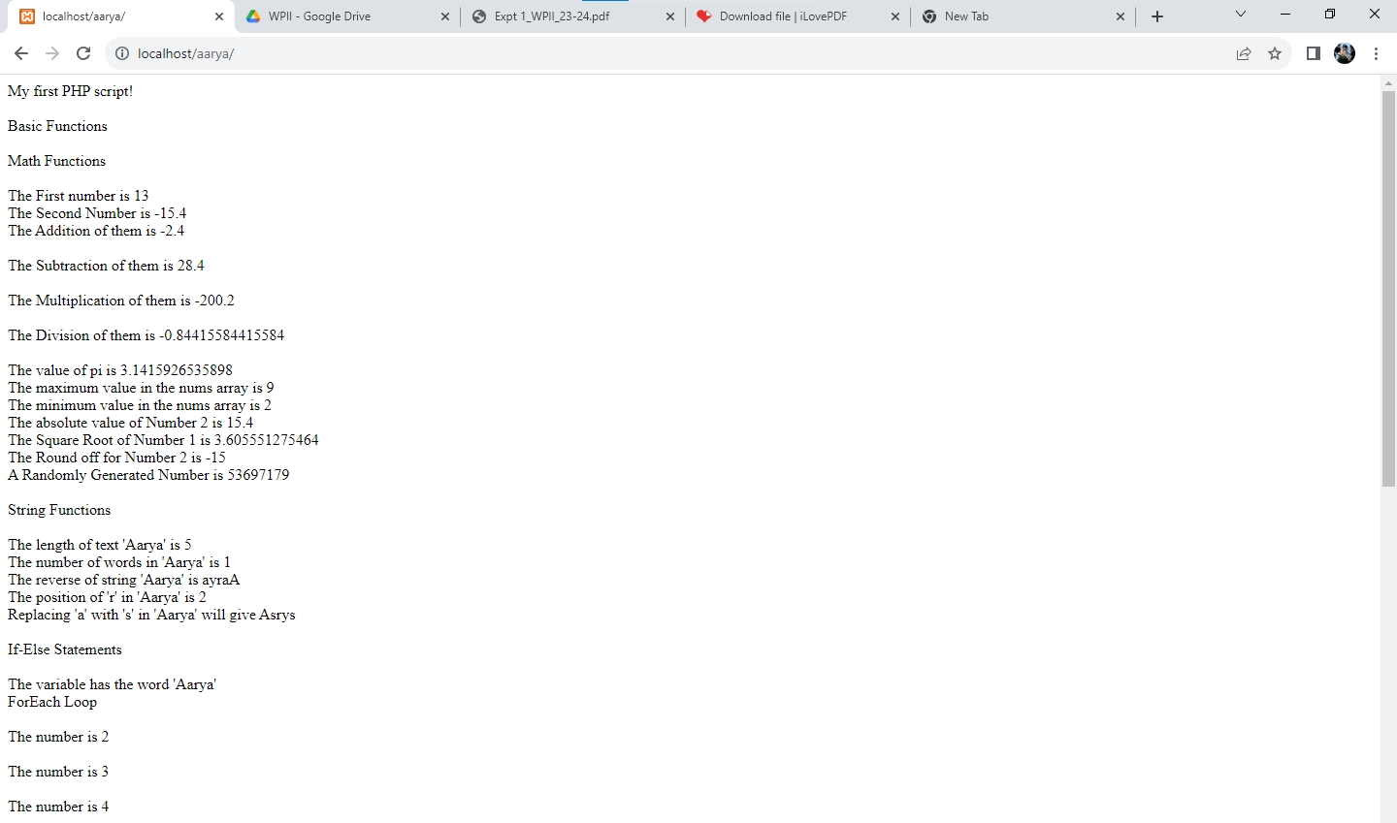

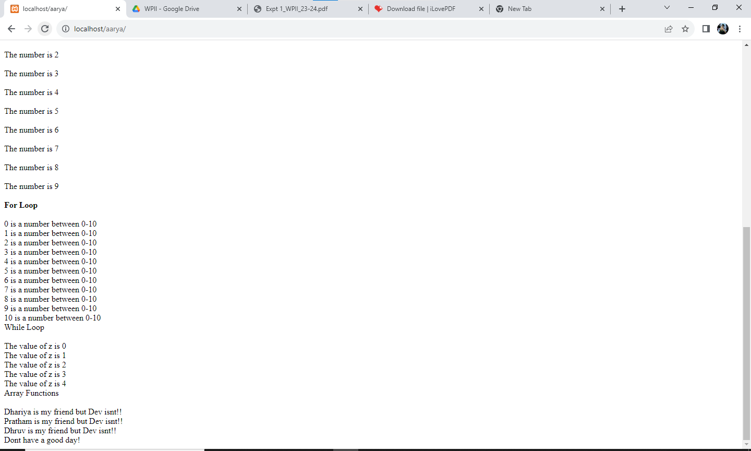

Post Lab Questions:

**Q1. Explain Loops in PHP**

Ans: Loops in PHP are used to execute the same block of code a specified number of times. PHP supports following four loop types.

* for − loops through a block of code a specified number of times.
* while − loops through a block of code if and as long as a specified condition is true.
* do...while − loops through a block of code once, and then repeats the loop as long as a special condition is true.
* foreach − loops through a block of code for each element in an array.

**Q2. Why chose PHP over other programming languages.**

Ans: PHP is a straightforward language with a simple syntax, making it easy to learn and use. It has a low learning curve, which makes it an excellent choice for beginners who are just starting with web development. Open-Source and Free: PHP is an open-source language, which means that it is free to use and distribute.

Outcomes:

CO1: Illustrate use of basic PHP concepts to build basic applications/

Conclusion:

We have learnt about basic PHP concepts